A
SYNOPSIS REPORT
ON

“ULTRASONIC DISTANCE MONITORING RADAR SYSTEM”

Session: 2025-26

DEPARTMENT OF COMPUTER SCIENCE AND ENGINEERING

NAGARJUNA INSTITUTE OF ENGINEERING TECHNOLOGY AND MANAGEMENT, NAGPUR
(As affiliated to Rashtrasant Tukdoji Maharaj Nagpur University)

Project submitted in partial fulfilment of the requirement for the degree of Bachelor of Technology in Computer Science & Engineering

SUBMITTED BY
DISHA NAGMOTE
PRIYANKA SHARMA
YASH BHALERAO
HARIKRUSHNA CHOPKAR
PRANAY UMREDKAR

GUIDED BY HEAD OF DEPARTMENT
Prof. Priya Farkade Prof. Atul Akotkar

NAGARJUNA INSTITUTE OF ENGINEERING TECHNOLOGY AND MANAGEMENT, NAGPUR

NAGARJUNA INSTITUTE OF ENGINEERING TECHNOLOGY AND MANAGEMENT, NAGPUR

COMPUTER SCIENCE AND ENGINEERING
CERTIFICATE
This is to certify that the dissertation titled

“ULTRASONIC DISTANCE MONITORING RADAR SYSTEM”
Has been successfully completed in session 2025-26 by
DISHA NAGMOTE
PRIYANKA SHARMA
YASH BHALERAO
HARIKRUSHNA CHOPKAR
PRANAY UMREDKAR
In recognition of the partial fullfilment for the degree of
Bachelor of Technology
(Computer Science & Engineering )
Rashtrasant Tukdoji Maharaj Nagpur University, Nagpur.

PROF.PRIYA FARKADE PROF. ATUL AKOTKAR
Project Guide Head of Department
NIETM, Nagpur NIETM, Nagpur

PROF. RASIK UPADHYE
Principal
NIETM, Nagpur

EXAMINER CERTIFICATE

This is to Certify that following Students

DISHA NAGMOTE
PRANAY UMREDKAR
PRIYANKA SHARMA
YASH BHALERAO
HARIKRUSHNA CHOPKAR

Of third year undergraduate Computer Science & Engineering
2025-2026 were examinee in the project work entitled

“ULTRASONIC DISTANCE MONITORING RADAR SYSTEM”

DATE: / /2026 PLACE: NAGPUR

INTERNAL EXAMINER EXTERNAL EXAMINER

DEPARTMENT OF COMPUTER SCIENCE AND ENGINEERING NAGARJUNA INSTITUTE OF ENGINEERING, TECHNOLOGY AND MANAGEMENT, NAGPUR
(RASHTRASANT TUKADOJI MAHARAJ NAGPUR UNIVERSITY

DECLARATION

We hereby certified that this report is being presented in the project report entitled “ULTRASONIC DISTANCE MONITORING RADAR SYSTEM” by use in partial fulfilment of requirements for award of Bachelor of Technology.
Submitted in the department of COMPUTER SCIENCE AND ENGINEERING is the record of our own work carried out during session 2025-2026, Guided by PROF. PRIYA FARKADE.

NAME AND SIGNATURE OF STUDENT

DISHA NAGMOTE PRIYANKA SHARMA

YASH BHALERAO PRANAY UMREDKAR

HARIKRUSHNA CHOPKAR

ACKNOWLEDGEMENT

We wish to express our heartfelt gratitude to all the people who have played a crucial role in the research for this project, without their active cooperation the preparation of this project could not have been completed within the specified time limit.

We are thankful to our respected Guide, Prof. Priya Farkade who supported us throughout this project with upmost cooperation and patience. Thank you for helping us in doing this project, for motivating us to complete this project with complete focus and attention.

We are also thankful to Head of Department Prof. Atul Akotkar and Principal Prof. Rasik Upadhye. It is their kind help and support that have made our study and life a wonderful time. Finally, we would like to express our gratitude to our family members, without their tremendous understanding and encouragement in the past few years, it would be impossible for us to complete our Study.

Our gratitude extends to the Rashtrasant Tukadoji Maharaj Nagpur University for giving us the opportunity to undertake our studies at the Department of Computer Science and Engineering, Nagarjuna Institute of Engineering Technology and Management, Nagpur.

INDEX
Sr. No. | Particulars | Page No.
 | Abstract
 | Introduction | 1
 | Literature Survey | 3
 | Project Methodology (Software & Hardware & tools) | 6
 | Advantages | 8
 | Disadvantages | 9
 | Data flow Diagram | 10
 | Code of Project | 11
 | Future Scope | 13
 | Result and Discussion | 15
 | Conclusion | 18
 | References | 19

Figure Table
Sr. No. | Name of figure | Page No.
 | Figure 1: Ultrasonic Radar System Prototype
 | Figure 2: Hardware requirements
 | Figure 3: Software requirements
 | Figure 4 : working model of system
 | Figure 5 : Table of Reference

ABSTRACT
The Ultrasonic Object Detection Radar System is a project designed to detect objects and measure their distance using ultrasonic sensor technology. The main objective of this system is to provide an efficient, reliable, and low-cost solution for object detection and obstacle avoidance in various real-world applications. This system operates by transmitting ultrasonic sound waves through a sensor, which then reflects back after hitting nearby objects. The time taken for the echo to return is calculated by the microcontroller to determine the exact distance of the object.
The system is implemented using a microcontroller, ultrasonic sensors, and a display unit to show real-time distance measurements. It is capable of detecting objects within a specific range with good accuracy and consistency. This technology plays an important role in improving automation and safety, especially in environments where manual monitoring is difficult or risky.
Furthermore, the project is simple in design, easy to implement, and cost-effective, making it suitable for students, beginners, and practical applications. It can be widely used in fields such as robotics, smart vehicles, industrial automation, and security systems. In addition, this system can help in reducing human effort and increasing operational efficiency.
In the future, this project can be enhanced by integrating advanced technologies such as artificial intelligence, wireless communication, and camera-based systems for improved accuracy and smart decision-making. Overall, the Ultrasonic Object Detection Radar System demonstrates an effective and practical use of ultrasonic technology for real-time object detection with reliable performance in different environment

.

CHAPTER 1
INTRODUCTION
1. Overview
The Ultrasonic Object Detection Radar System is a modern technology-based project that is used to detect objects and measure their distance using ultrasonic sensor technology. In today’s world, technology is growing very fast and automation is becoming an important part of our daily life. Many industries and systems now depend on automatic detection and monitoring to improve safety, accuracy, and efficiency. This project focuses on developing a simple, reliable, and cost-effective system that can detect objects in real time.
The main idea behind this system is to use ultrasonic waves for detecting objects without any physical contact. The system can be used in different fields such as robotics, vehicles, and security systems. It helps in reducing human effort and provides quick and accurate results.
2. Background of the Study
In earlier times, object detection was mostly done manually, which was not only time-consuming but also less accurate. With the advancement of science and technology, different types of sensors have been developed to solve this problem. Among them, ultrasonic sensors are widely used because they are simple, affordable, and efficient.
Ultrasonic technology works on the principle of sound waves. These sensors send high-frequency sound waves which are not audible to humans. When these waves hit an object, they reflect back to the sensor. By calculating the time taken for the wave to return, the distance of the object can be measured.
This method is widely used in many real-life applications such as parking sensors in cars, robotic movement, and obstacle detection systems. Due to its reliability and ease of use, ultrasonic technology has become an important part of modern electronic systems.
3. Problem Statement
In many real-life situations, detecting objects or obstacles manually can be difficult and unsafe. For example, in driving, robotics, or industrial environments, a small mistake in detecting an object can lead to serious problems or accidents. Manual systems are not always accurate and require continuous human attention.
Also, some existing automatic detection systems are expensive and complex, which makes them unsuitable for small-scale or educational use. Therefore, there is a need for a system that is simple, affordable, and efficient in detecting objects accurately.
This project aims to solve these problems by developing an ultrasonic-based object detection system that can work automatically and provide real-time distance measurement.

4. Purpose of the Project
The main purpose of this project is to design and develop an efficient object detection system using ultrasonic sensors. The system should be able to detect objects and measure their distance accurately without any human involvement.
Another purpose of this project is to provide a low-cost solution that can be easily used by students, beginners, and in small applications. The project also helps in understanding the working of sensors and microcontrollers in a practical way.
Overall, the project aims to improve safety, reduce manual work, and provide a reliable system for object detection.
5. Scope of the Project
The scope of this project is focused on developing a basic prototype of an ultrasonic object detection system. The system will be able to detect objects within a limited range and display the distance in real time.
This project can be used in many applications such as robotics, vehicle parking systems, and security systems. It can also be expanded in the future by adding more advanced features like wireless communication, camera integration, and artificial intelligence.
Although the current system is simple, it provides a strong foundation for developing more complex and advanced systems in the future.
6. Significance of the Study
This project is important because it shows how technology can be used to solve real-world problems in a simple and effective way. The ultrasonic object detection system helps in improving safety and efficiency in different applications.
It reduces the need for human effort and provides accurate results in a short time. This makes it useful in areas where quick decision-making is required.
Moreover, this project is very useful for students as it helps them understand the practical use of sensors and microcontrollers. It also encourages learning and innovation in the field of electronics and automation.
7. Advantages of the System
The ultrasonic object detection system has several advantages. It is simple to design and easy to use. It does not require physical contact with objects, which makes it safe and reliable. The system is cost-effective and can be implemented easily using basic components.
It provides accurate distance measurement and works efficiently in different environments. The system can also be modified and improved based on requirements, making it flexible for various applications.

8. Limitations of the System
Although the system is useful, it also has some limitations. The accuracy of the system may be affected by environmental conditions such as temperature, humidity, and noise. It may not work properly with very soft or irregular surfaces that do not reflect sound waves effectively.
The detection range is also limited, which means it cannot detect objects at very long distances. Despite these limitations, the system performs well for short-range detection and basic applications.
9. Future Enhancements
In the future, this project can be improved by adding advanced features such as wireless communication, mobile app control, and camera-based detection. Artificial intelligence can also be integrated to make the system smarter and more efficient.
The system can be expanded for use in autonomous vehicles, smart homes, and advanced robotics. These improvements will increase the accuracy, range, and overall performance of the system.

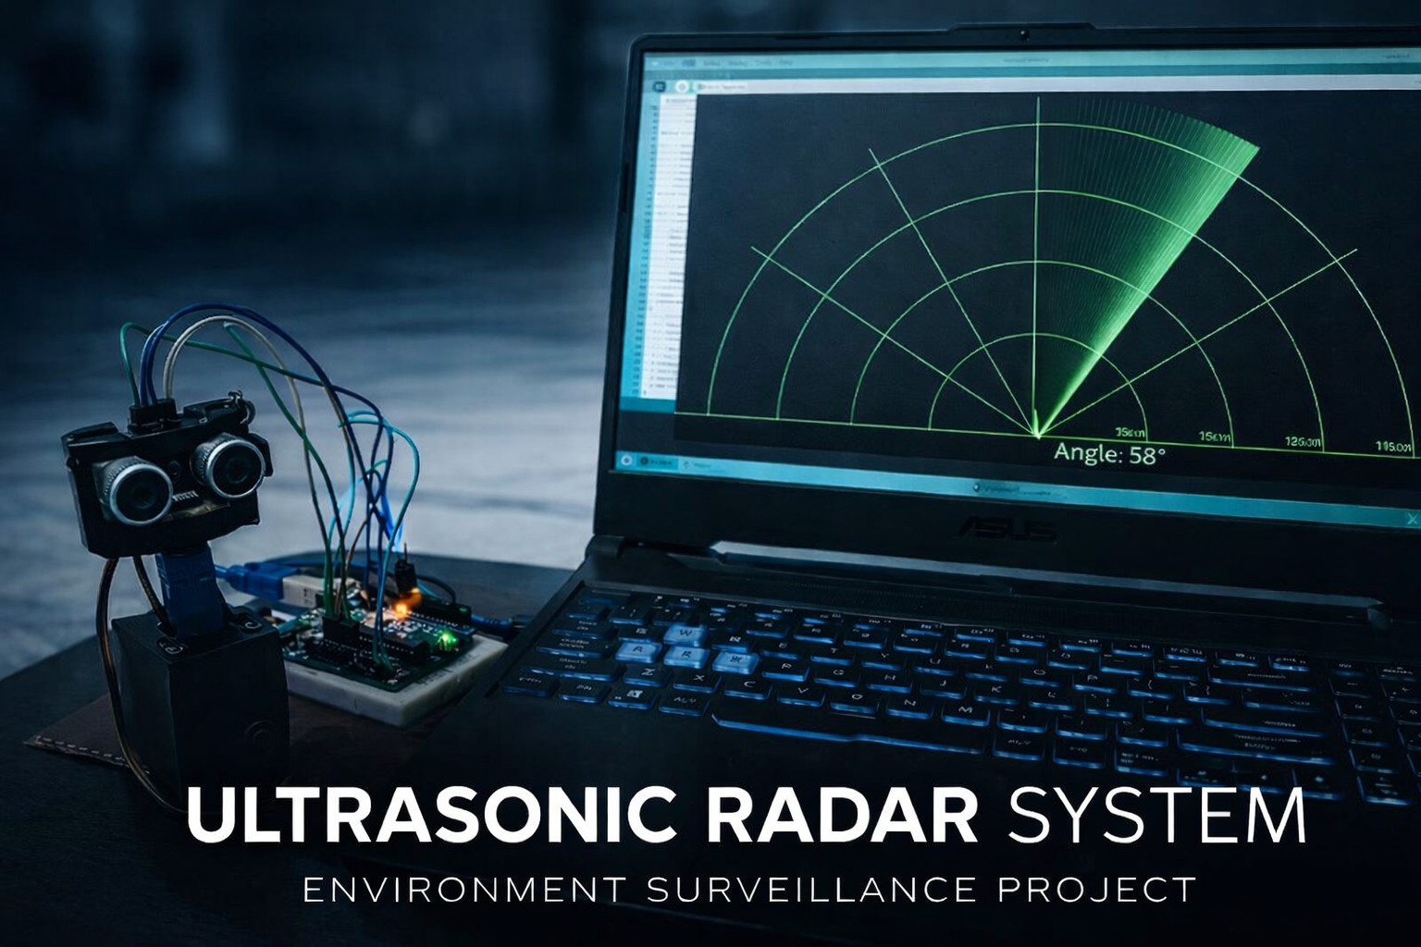
(Figure 1: Ultrasonic Radar System Prototype)

CHAPTER 2
LITERATURE SURVEY
[1] Valérie Ciarletti (2016)

This study presents a variety of radar systems developed to explore the hidden structures and physical properties of planets and other celestial bodies in the Solar System. The research explains how radar waves are used for subsurface detection and deep surface analysis. It highlights the importance of radar technology in space exploration and scientific investigations. Different radar configurations and their operational capabilities are also discussed. The paper emphasizes accuracy, reliability, and advanced applications of radar systems. This work provides a strong theoretical base for understanding modern radar technologies.
[2] Ahman Emmanuel Onoja & Abdusalaam Maryam Oluwadamilola (2017)

This paper focuses on the design and implementation of a radar system using Arduino and an ultrasonic sensor. The system is capable of detecting objects and measuring distance in real time using ultrasonic waves. It demonstrates the application of embedded systems in developing low-cost radar solutions. The study highlights simple hardware design and ease of implementation. It also shows how real-time data can be processed effectively using microcontrollers. This work serves as a practical reference for basic radar system development.
[3] Shengbo Eben Li et al. (2018)

This research introduces a method for tracking moving objects using a linear ultrasonic sensor array. The study applies a Kalman filter algorithm to improve tracking accuracy and predict object movement. It is specifically designed for road vehicle applications and real-time environments. The paper focuses on enhancing detection performance and minimizing errors. Advanced signal processing techniques are used to achieve reliable results. This work contributes to the development of intelligent sensing and tracking systems.
[4] A. K. Shrivastava et al.

This study discusses the measurement of distance using ultrasonic sensors based on the time-of-flight principle. It explains how the time taken by ultrasonic waves to reflect from an object is used to calculate distance accurately. The system is simple, efficient, and suitable for short-range measurements. The research highlights its applications in obstacle detection and automation systems. It also emphasizes ease of implementation and cost-effectiveness. This work provides fundamental knowledge of ultrasonic sensing techniques.

CHAPTER 3
Project Methodology (Software & Hardware Requirement)

PROJECT METHODOLOGY:

The methodology of the Ultrasonic Distance Monitoring Radar System focuses on the design and implementation of a system capable of detecting objects and measuring their distance using ultrasonic sensing technology. The system integrates hardware components such as ultrasonic sensors, a microcontroller, and a servo motor with software programming to perform real-time monitoring and visualization.

HARDWARE REQUIREMENTS:

Hardware component | Technical utility | Qty
Ultrasonic Sensor (HC-SR04) | Used to measure distance by sending and receiving ultrasonic waves. | 1
Microcontroller Arduino uno | Processes sensor data and controls the system operation. | 1
Servo Motor | Rotates the ultrasonic sensor to scan objects at different angles. | 1
Jumper wires(M-F , F-M) | Used to connect electronic components in the circuit. | 1 set
Ardiuino cable | Used to upload program and provide connection to the computer. | 1

(Figure 3: Hardware requirements)

SOFTWARE REQUIREMENT :

SOFTWARE | TECHNICAL UTILITY
Arduino Integrated Development Environment (IDE) | Used to write, compile, and upload the program to the Arduino microcontroller.
Processing Integrated Development Environment (IDE) | Used to create a graphical interface to visualize radar scanning and display detected objects in real time on the screen.
C Programming | Used to program the microcontroller and control the system.
(Figure 3: software requirements)

Working Principle of the System :

The Ultrasonic Distance Monitoring Radar System works on the principle of ultrasonic sound wave reflection. The system is designed to detect objects and measure their distance using an ultrasonic sensor integrated with a microcontroller and a servo motor. The entire system combines hardware components and software programming to perform real-time object detection and monitoring.
Initially, the ultrasonic sensor (HC-SR04) generates high-frequency ultrasonic sound waves and transmits them into the surrounding environment. When these ultrasonic waves encounter an object, they are reflected back toward the sensor in the form of echo signals. The sensor contains two main parts: a transmitter and a receiver. The transmitter sends ultrasonic pulses, while the receiver captures the reflected echo signals.

Working Principle of Ultrasonic Distance Monitoring Radar System
The Ultrasonic Distance Monitoring Radar System works on the principle of ultrasonic sound wave reflection. The system is designed to detect objects and measure their distance using an ultrasonic sensor integrated with a microcontroller and a servo motor. The entire system combines hardware components and software programming to perform real-time object detection and monitoring.
Initially, the ultrasonic sensor (HC-SR04) generates high-frequency ultrasonic sound waves and transmits them into the surrounding environment. When these ultrasonic waves encounter an object, they are reflected back toward the sensor in the form of echo signals. The sensor contains two main parts: a transmitter and a receiver. The transmitter sends ultrasonic pulses, while the receiver captures the reflected echo signals.
Once the echo signal is received, the microcontroller (Arduino) measures the time taken by the ultrasonic wave to travel from the sensor to the object and return back. This time duration is used to calculate the distance between the sensor and the object using the speed of sound in air. The calculated distance value is then processed by the microcontroller.
In order to create a radar-like scanning effect, the servo motor is used to rotate the ultrasonic sensor across different angles. As the servo motor rotates, the sensor scans the surrounding area from one side to another. During this rotation, the sensor continuously sends ultrasonic signals and receives echo signals from objects present in different directions.
The Arduino microcontroller processes the obtained distance data and sends the information to the computer through serial communication. The Processing IDE software receives this data and converts it into a graphical representation. The detected objects are displayed on the computer screen in the form of a radar-like interface that shows the position and distance of objects within the scanning range.
This system allows real-time monitoring of objects and demonstrates the practical implementation of embedded systems, sensor technology, and microcontroller programming. The integration of hardware components and software tools enables the system to perform efficient and accurate distance measurement and environmental scanning.
Thus, the system effectively demonstrates the practical implementation of ultrasonic sensing and embedded system technology for accurate object detection and distance monitoring.

Chapter 4
Advantages

- Provides accurate distance measurement using ultrasonic sensing technology.

- The system is cost-effective and easy to implement.

- It allows real-time object detection and monitoring.

- Helps in understanding the practical application of embedded systems.

- Can be used in robotics, security systems, and automation applications.

- The system is simple, reliable, and efficient for distance monitoring

Chapter 5
Disadvantages

- The system has a limited detection range.

- Accuracy may be affected by environmental conditions such as noise or temperature.

- Ultrasonic sensors may not detect very small or soft objects properly.

- The system requires proper alignment of components for accurate results.

- It can detect objects only within the sensor’s scanning area.

Chapter 6
Data Flow Diagram :

Working Diagram: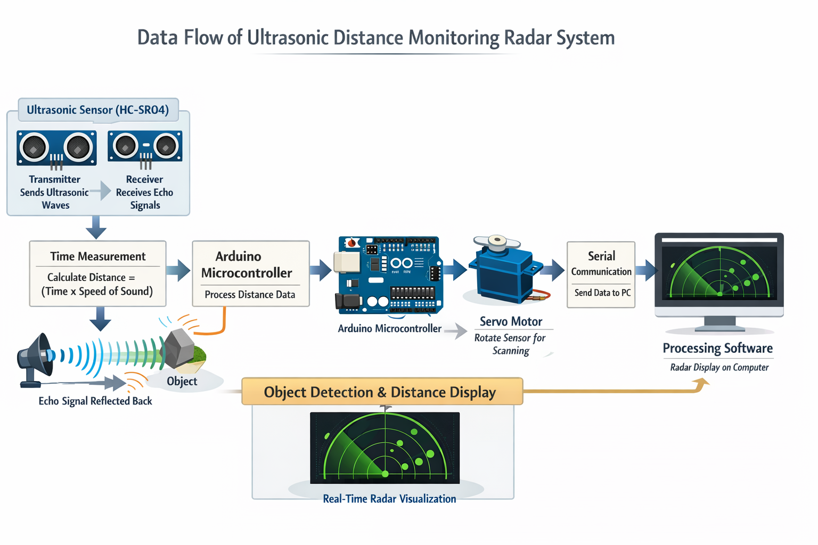

(Fig 4 : working model of system )

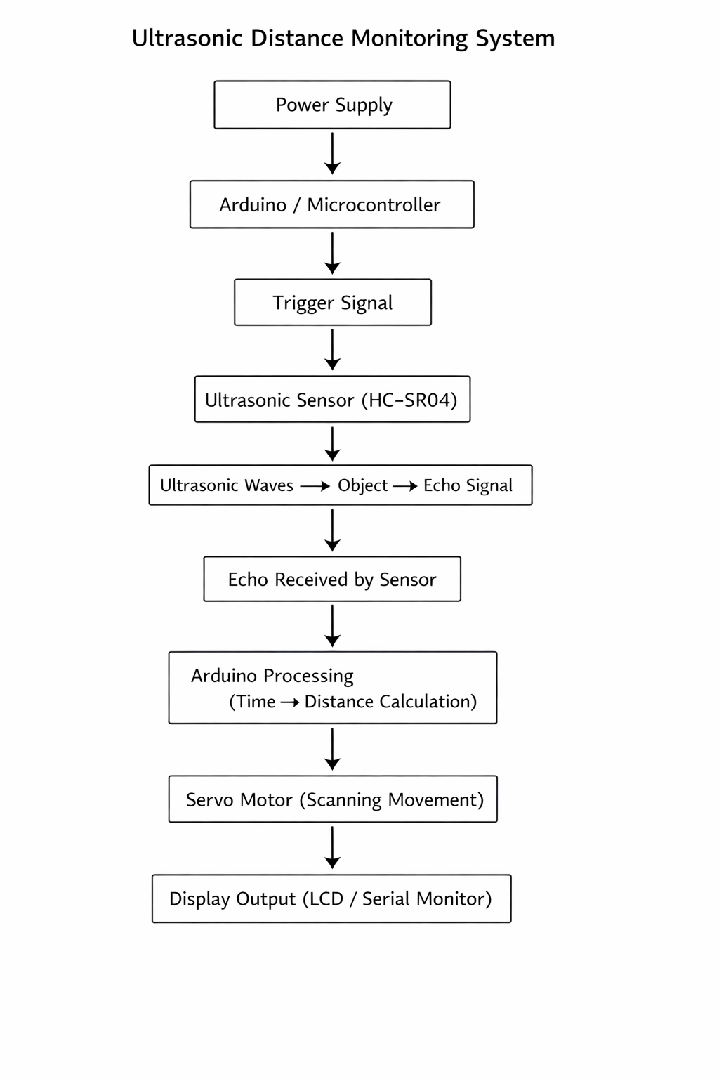
Chapter 7
Code of Project :

Arduino Program Code :

#include <Servo.h>

const int trigPin = 8;
const int echoPin = 9;

long duration;
int distance;

Servo myServo;

void setup() {
pinMode(trigPin, OUTPUT);
pinMode(echoPin, INPUT);
Serial.begin(9600);
myServo.attach(10);
}

void loop() {
// Servo rotation and distance measurement
myServo.write(90);
delay(30);

distance = calculateDistance();

Serial.print("Angle: ");
Serial.print(90);
Serial.print(", Distance: ");
Serial.println(distance);
}

// Function to calculate distance
int calculateDistance(){
digitalWrite(trigPin, LOW);
delayMicroseconds(2);

digitalWrite(trigPin, HIGH);
delayMicroseconds(10);
digitalWrite(trigPin, LOW);

duration = pulseIn(echoPin, HIGH);
distance = duration * 0.034 / 2;

return distance;
}

PROCESSING IDE PROGRAM CODE :

import processing.serial.*;

Serial myPort;
String data = "";
int angle = 0;
int distance = 0;

void setup() {
size(600, 600); // Window size
myPort = new Serial(this, "COM3", 9600);
myPort.bufferUntil('.');
}

void draw() {
background(0);

// Read serial data
if (myPort.available() > 0) {
data = myPort.readStringUntil('.');

if (data != null) {
data = trim(data);
int commaIndex = data.indexOf(',');

if (commaIndex > 0) {
angle = int(data.substring(0, commaIndex));
distance = int(data.substring(commaIndex + 1));
}
}
}

// Radar line
stroke(0, 255, 0);
line(width/2, height,
width/2 + cos(radians(angle)) * 250,
height - sin(radians(angle)) * 250);

// Display text
fill(0, 255, 0);
text("Angle: " + angle, 20, 30);
text("Distance: " + distance, 20, 50);
}

Note: The above code represents only the main logic of the project for understanding the working principle. The complete program code is not included here and is provided separately in the appendix.

CHAPTER 8
Future Scope

- The system can be further developed into a defense surveillance radar system for border monitoring and intrusion detection.

- It can be integrated into autonomous robots and drones for intelligent navigation and obstacle avoidance in complex environments.

- The project can be extended into a smart traffic monitoring system for vehicle detection and congestion analysis in smart cities.

- It can be used in self-driving vehicles as a part of obstacle detection and collision avoidance systems.

- The system can be enhanced with Artificial Intelligence and Computer Vision for real-time object recognition and decision-making.

- It can be applied in industrial automation systems for safety monitoring, hazard detection, and automatic machine control.

- It can be used in security systems for motion detection and unauthorized access monitoring in restricted areas.

- The system can be integrated with IoT (Internet of Things) for remote monitoring, data logging, and cloud-based control.

- It can be applied in medical and assistive devices such as smart navigation systems for visually impaired people.

- The project can be expanded into a smart home automation system for presence detection and energy management.

- It can be used in space exploration robots for terrain mapping and obstacle detection on unknown surfaces.

CHAPTER 9
RESULT AND DISCUSSION

Result
The Ultrasonic Radar System was successfully designed and implemented. The system was able to detect objects and measure their distance accurately using the ultrasonic sensor. The servo motor rotated smoothly from 15° to 165°, providing effective scanning of the surrounding area.
The measured distance and corresponding angle were transmitted through serial communication to the Processing IDE. The radar visualization displayed the position of objects in real time, indicating both angle and distance clearly. The system responded quickly and produced consistent output during testing.

Discussion
The performance of the system shows that ultrasonic sensing is an effective method for short-range object detection. The integration of the servo motor allowed the system to cover a wide scanning range, improving detection capability.
However, slight variations in distance measurement were observed due to environmental conditions such as object surface, angle of reflection, and external noise. Despite these minor limitations, the system performed reliably and achieved its intended objectives.
The project demonstrates a simple and cost-effective approach to radar-based detection, which can be further enhanced for advanced applications such as robotics and automation.

CHAPTER 10
CONCLUSION

- The project successfully demonstrates the use of an ultrasonic sensor with Arduino for real-time object detection and distance measurement.
- It effectively simulates a basic radar system by providing visual representation of detected objects.
- The system is simple in design, making it easy to understand, implement, and modify.
- It is cost-effective, using readily available components like Arduino, ultrasonic sensor, and servo motor.
- The real-time radar visualization enhances user interaction and improves monitoring capability.
- The accuracy of distance measurement is satisfactory for short-range applications.
- This project provides a strong foundation for learning embedded systems, sensors, and automation.
- It can be further enhanced by integrating wireless communication, IoT, or advanced sensors for wider applications such as security systems, obstacle avoidance, and surveillance.
- Overall, the project proves to be an efficient and practical implementation of a mini radar system using ultrasonic technology.

CHAPTER 11
REFERENCE

[1] Valérie Ciarletti,” A variety of radars designed to explore the hid den structures and properties of the Solar System’s planets and bod ies”, Comptes Rendus Physique, C. R. Physique, Elsever, (2016), pp.966-975.
. [2] Ahman Emmanuel Onoja & Abdusalaam Maryam Oluwadamilola,” Embedded System Based Radio Detection and Ranging (RADAR) System Using Arduino and Ultra-Sonic Sensor, Vol.2, No.5,(2017), pp.85-90.
[3] Shengbo Eben Li, Guofa Li, Jiaying Yu, Chang Liu, Bo Cheng, Jianqiang Wang & Keqiang Li,” Kalman filter-based tracking of moving objects using linear ultrasonic sensor array for road vehi cles”, elsever (2018), pp:173-189
[4] A. K. Shrivastava, A. Verma, & S. P. Singh, ” Distance Measure ment of an Object or Obstacle by Ultrasound Sensors using

.

